**NAME**: NITHYA SHREE A ( BE.CSE)

**YEAR OF STUDYING**: III YEAR

**GIT REPOSITORY** : <https://github.com/nithya-shree-1603/port.git>

**INTERNSHIP:** Microsoft azure fundamentals at PINESPHERE,

COIMBATORE.

From 06.08.2024 to 10.08.2024

Working in Microsoft Azure :

Contents:

1. Creation of virtual machine.
2. Deploying git repository in VM.
3. Creation of Storage account(Blob creation).
4. Creation of static web apps to deploy git repository.

1.Creation of virtual machine:

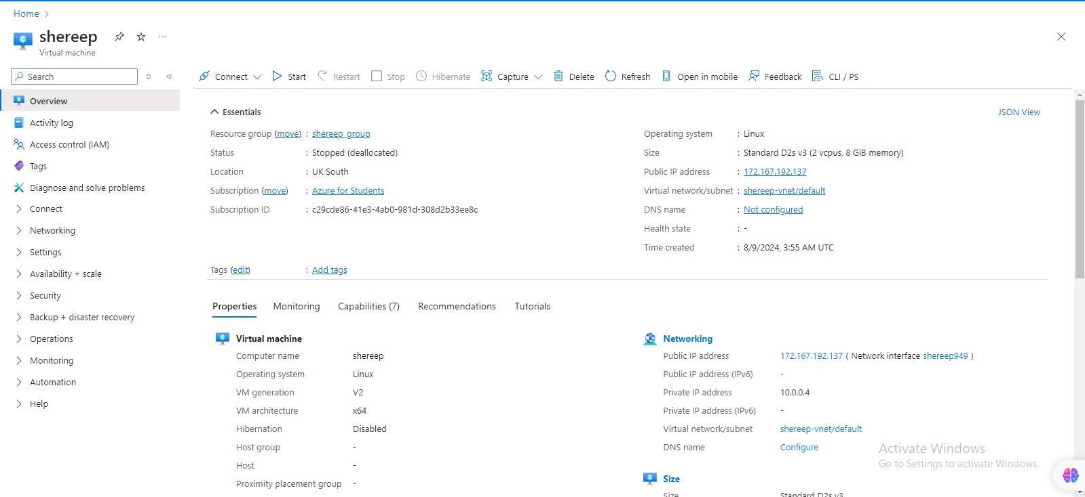

2. Deploying git repository in VM:

Requesting a Cloud Shell.Succeeded.

Connecting terminal...

Your Cloud Shell session will be ephemeral so no files or system changes will persist beyond your current session.

nithyashreeanabazhagan[ ~ ]$ ssh shereep@ 172.167.192.137

The authenticity of host '20.244.108.149 (20.244.108.149)' can't be established.

ED25519 key fingerprint is SHA256:46+FQ7nhkKu1NTB6CfeviJ9ByolchIZXDaeKhc8cDBs.

This key is not known by any other names

Are you sure you want to continue connecting (yes/no/[fingerprint])? yes

Warning: Permanently added ‘172.167.192.137' (ED25519) to the list of known hosts.

shereep@ 172.167.192.137's password:

Welcome to Ubuntu 24.04 LTS (GNU/Linux 6.8.0-1010-azure x86_64)

* Documentation: https://help.ubuntu.com

* Management: https://landscape.canonical.com

* Support: https://ubuntu.com/pro

System information as of Fri Aug 9 03:56:50 UTC 2024

System load: 0.33 Processes: 135

Usage of /: 5.0% of 28.02GB Users logged in: 0

Memory usage: 3% IPv4 address for eth0: 10.2.0.4

Swap usage: 0%

Expanded Security Maintenance for Applications is not enabled.

0 updates can be applied immediately.

Enable ESM Apps to receive additional future security updates.

See https://ubuntu.com/esm or run: sudo pro status

The programs included with the Ubuntu system are free software;

the exact distribution terms for each program are described in the

individual files in /usr/share/doc/*/copyright.

Ubuntu comes with ABSOLUTELY NO WARRANTY, to the extent permitted by

applicable law.

To run a command as administrator (user "root"), use "sudo <command>".

See "man sudo_root" for details.

nithyashreeanbazhagan@shereep:~$ sudo apt update

Hit:1 http://azure.archive.ubuntu.com/ubuntu noble InRelease

Get:2 http://azure.archive.ubuntu.com/ubuntu noble-updates InRelease [126 kB]

Get:3 http://azure.archive.ubuntu.com/ubuntu noble-backports InRelease [126 kB]

Get:4 http://azure.archive.ubuntu.com/ubuntu noble-security InRelease [126 kB]

Get:5 http://azure.archive.ubuntu.com/ubuntu noble/universe amd64 Packages [15.0 MB]

Get:6 http://azure.archive.ubuntu.com/ubuntu noble/universe Translation-en [5982 kB]

Get:7 http://azure.archive.ubuntu.com/ubuntu noble/universe amd64 Components [3871 kB]

Get:8 http://azure.archive.ubuntu.com/ubuntu noble/universe amd64 c-n-f Metadata [301 kB]

Get:9 http://azure.archive.ubuntu.com/ubuntu noble/multiverse amd64 Packages [269 kB]

Get:10 http://azure.archive.ubuntu.com/ubuntu noble/multiverse Translation-en [118 kB]

Get:11 http://azure.archive.ubuntu.com/ubuntu noble/multiverse amd64 Components [35.0 kB]

Get:12 http://azure.archive.ubuntu.com/ubuntu noble/multiverse amd64 c-n-f Metadata [8328 B]

Get:13 http://azure.archive.ubuntu.com/ubuntu noble-updates/main amd64 Packages [340 kB]

Get:14 http://azure.archive.ubuntu.com/ubuntu noble-updates/main Translation-en [86.2 kB]

Get:15 http://azure.archive.ubuntu.com/ubuntu noble-updates/main amd64 c-n-f Metadata [5704 B]

Get:16 http://azure.archive.ubuntu.com/ubuntu noble-updates/universe amd64 Packages [321 kB]

Get:17 http://azure.archive.ubuntu.com/ubuntu noble-updates/universe Translation-en [135 kB]

Get:18 http://azure.archive.ubuntu.com/ubuntu noble-updates/universe amd64 Components [45.0 kB]

Get:19 http://azure.archive.ubuntu.com/ubuntu noble-updates/universe amd64 c-n-f Metadata [12.7 kB]

Get:20 http://azure.archive.ubuntu.com/ubuntu noble-updates/restricted amd64 Packages [237 kB]

Get:21 http://azure.archive.ubuntu.com/ubuntu noble-updates/restricted Translation-en [46.4 kB]

Get:22 http://azure.archive.ubuntu.com/ubuntu noble-updates/multiverse amd64 Packages [14.1 kB]

Get:23 http://azure.archive.ubuntu.com/ubuntu noble-updates/multiverse Translation-en [3608 B]

Get:24 http://azure.archive.ubuntu.com/ubuntu noble-updates/multiverse amd64 Components [212 B]

Get:25 http://azure.archive.ubuntu.com/ubuntu noble-updates/multiverse amd64 c-n-f Metadata [532 B]

Get:26 http://azure.archive.ubuntu.com/ubuntu noble-backports/main amd64 Components [208 B]

Get:27 http://azure.archive.ubuntu.com/ubuntu noble-backports/main amd64 c-n-f Metadata [112 B]

Get:28 http://azure.archive.ubuntu.com/ubuntu noble-backports/universe amd64 Packages [10.3 kB]

Get:29 http://azure.archive.ubuntu.com/ubuntu noble-backports/universe Translation-en [10.5 kB]

Get:30 http://azure.archive.ubuntu.com/ubuntu noble-backports/universe amd64 Components [17.6 kB]

Get:31 http://azure.archive.ubuntu.com/ubuntu noble-backports/universe amd64 c-n-f Metadata [1016 B]

Get:32 http://azure.archive.ubuntu.com/ubuntu noble-backports/restricted amd64 Components [216 B]

Get:33 http://azure.archive.ubuntu.com/ubuntu noble-backports/restricted amd64 c-n-f Metadata [116 B]

Get:34 http://azure.archive.ubuntu.com/ubuntu noble-backports/multiverse amd64 Components [212 B]

Get:35 http://azure.archive.ubuntu.com/ubuntu noble-backports/multiverse amd64 c-n-f Metadata [116 B]

Get:36 http://azure.archive.ubuntu.com/ubuntu noble-security/main amd64 Packages [288 kB]

Get:37 http://azure.archive.ubuntu.com/ubuntu noble-security/main Translation-en [66.6 kB]

Get:38 http://azure.archive.ubuntu.com/ubuntu noble-security/main amd64 c-n-f Metadata [3696 B]

Get:39 http://azure.archive.ubuntu.com/ubuntu noble-security/universe amd64 Packages [249 kB]

Get:40 http://azure.archive.ubuntu.com/ubuntu noble-security/universe Translation-en [108 kB]

Get:41 http://azure.archive.ubuntu.com/ubuntu noble-security/universe amd64 Components [8632 B]

Get:42 http://azure.archive.ubuntu.com/ubuntu noble-security/universe amd64 c-n-f Metadata [9376 B]

Get:43 http://azure.archive.ubuntu.com/ubuntu noble-security/restricted amd64 Packages [237 kB]

Get:44 http://azure.archive.ubuntu.com/ubuntu noble-security/restricted Translation-en [46.4 kB]

Get:45 http://azure.archive.ubuntu.com/ubuntu noble-security/multiverse amd64 Packages [10.6 kB]

Get:46 http://azure.archive.ubuntu.com/ubuntu noble-security/multiverse Translation-en [2808 B]

Get:47 http://azure.archive.ubuntu.com/ubuntu noble-security/multiverse amd64 Components [208 B]

Get:48 http://azure.archive.ubuntu.com/ubuntu noble-security/multiverse amd64 c-n-f Metadata [344 B]

Fetched 28.3 MB in 5s (6201 kB/s)

Reading package lists... Done

Building dependency tree... Done

Reading state information... Done

7 packages can be upgraded. Run 'apt list --upgradable' to see them.

ramyav@myvm2:~$ sudo apt install git

Reading package lists... Done

Building dependency tree... Done

Reading state information... Done

git is already the newest version (1:2.43.0-1ubuntu7.1).

git set to manually installed.

0 upgraded, 0 newly installed, 0 to remove and 7 not upgraded.

nithyashreeanbazhagan@shereep:~$ sudo apt install nginx

Reading package lists... Done

Building dependency tree... Done

Reading state information... Done

The following additional packages will be installed:

nginx-common

Suggested packages:

fcgiwrap nginx-doc ssl-cert

The following NEW packages will be installed:

nginx nginx-common

0 upgraded, 2 newly installed, 0 to remove and 7 not upgraded.

Need to get 552 kB of archives.

After this operation, 1596 kB of additional disk space will be used.

Do you want to continue? [Y/n] y

Get:1 http://azure.archive.ubuntu.com/ubuntu noble/main amd64 nginx-common all 1.24.0-2ubuntu7 [31.2 kB]

Get:2 http://azure.archive.ubuntu.com/ubuntu noble/main amd64 nginx amd64 1.24.0-2ubuntu7 [521 kB]

Fetched 552 kB in 0s (12.4 MB/s)

Preconfiguring packages ...

Selecting previously unselected package nginx-common.

(Reading database ... 64517 files and directories currently installed.)

Preparing to unpack .../nginx-common_1.24.0-2ubuntu7_all.deb ...

Unpacking nginx-common (1.24.0-2ubuntu7) ...

Selecting previously unselected package nginx.

Preparing to unpack .../nginx_1.24.0-2ubuntu7_amd64.deb ...

Unpacking nginx (1.24.0-2ubuntu7) ...

Setting up nginx (1.24.0-2ubuntu7) ...

Setting up nginx-common (1.24.0-2ubuntu7) ...

Created symlink /etc/systemd/system/multi-user.target.wants/nginx.service → /usr/lib/systemd/system/nginx.service.

Processing triggers for ufw (0.36.2-6) ...

Processing triggers for man-db (2.12.0-4build2) ...

Scanning processes...

Scanning linux images...

Running kernel seems to be up-to-date.

No services need to be restarted.

No containers need to be restarted.

No user sessions are running outdated binaries.

No VM guests are running outdated hypervisor (qemu) binaries on this host.

nithyashreeanbazhagan@shereep:~$ sudo systemctl start nginx

nithyashreeanbazhagan@shereep:~$ sudo systemctl enable nginx

Synchronizing state of nginx.service with SysV service script with /usr/lib/systemd/systemd-sysv-install.

Executing: /usr/lib/systemd/systemd-sysv-install enable nginx

nithyashreeanbazhagan@shereep:~$ cd /var/www/html

nithyashreeanbazhagan@shereep:/var/www/html$ sudo rm -rf *

nithyashreeanbazhagan@shereep:/var/www/html$ sudo git clone <https://github.com/nithya-shree-1603/port.git>

Cloning into '.'...

remote: Enumerating objects: 9, done.

remote: Counting objects: 100% (9/9), done.

remote: Compressing objects: 100% (7/7), done.

remote: Total 9 (delta 1), reused 0 (delta 0), pack-reused 0

Receiving objects: 100% (9/9), 5.20 KiB | 70.00 KiB/s, done.

Resolving deltas: 100% (1/1), done.

nithyashreeanbazhagan@shereep:/var/www/html$ sudo chown -R www-data:www-data /var/www/html

nithyashreeanbazhagan@shereep:/var/www/html$

**output:**

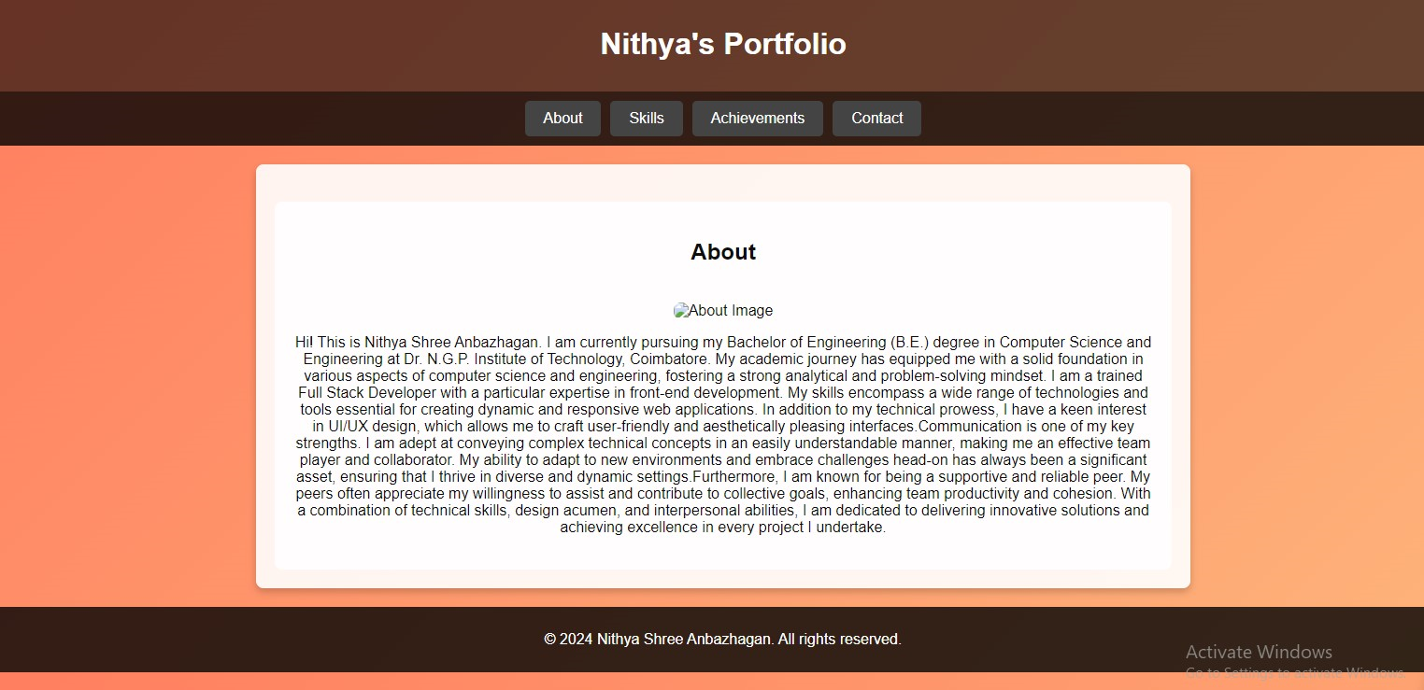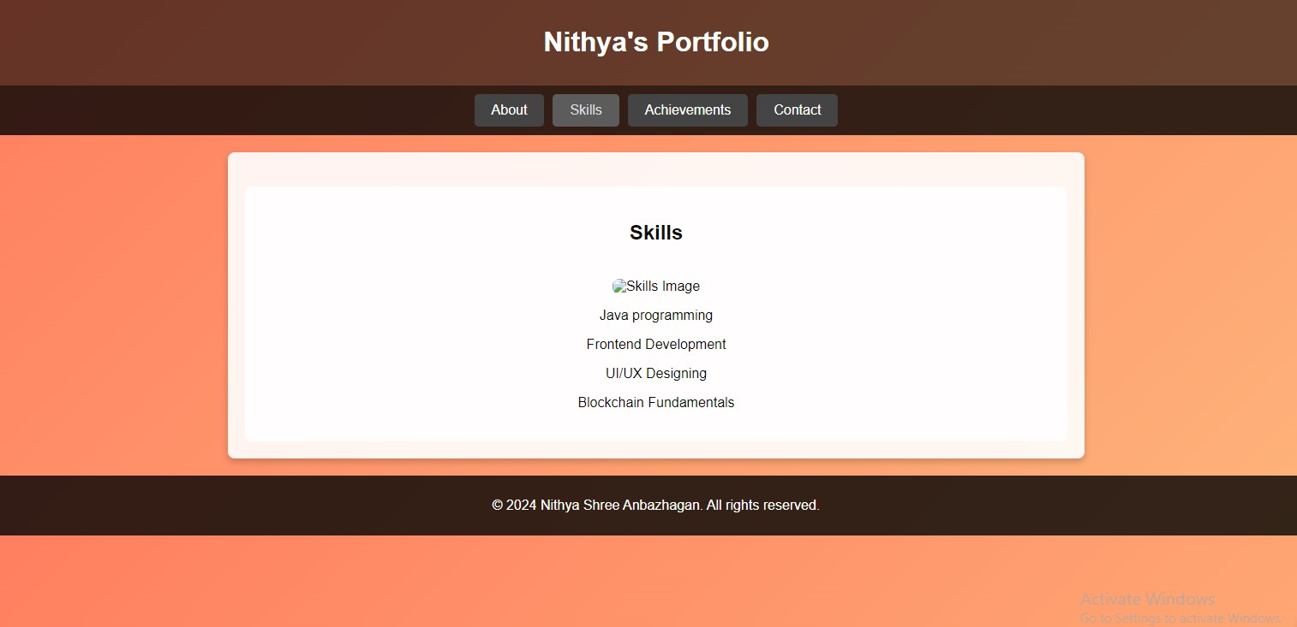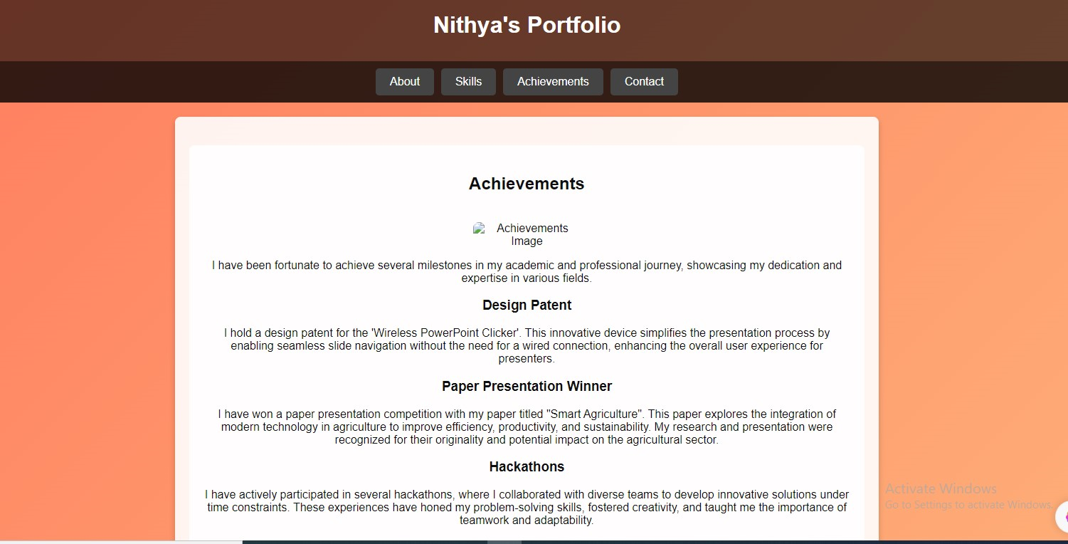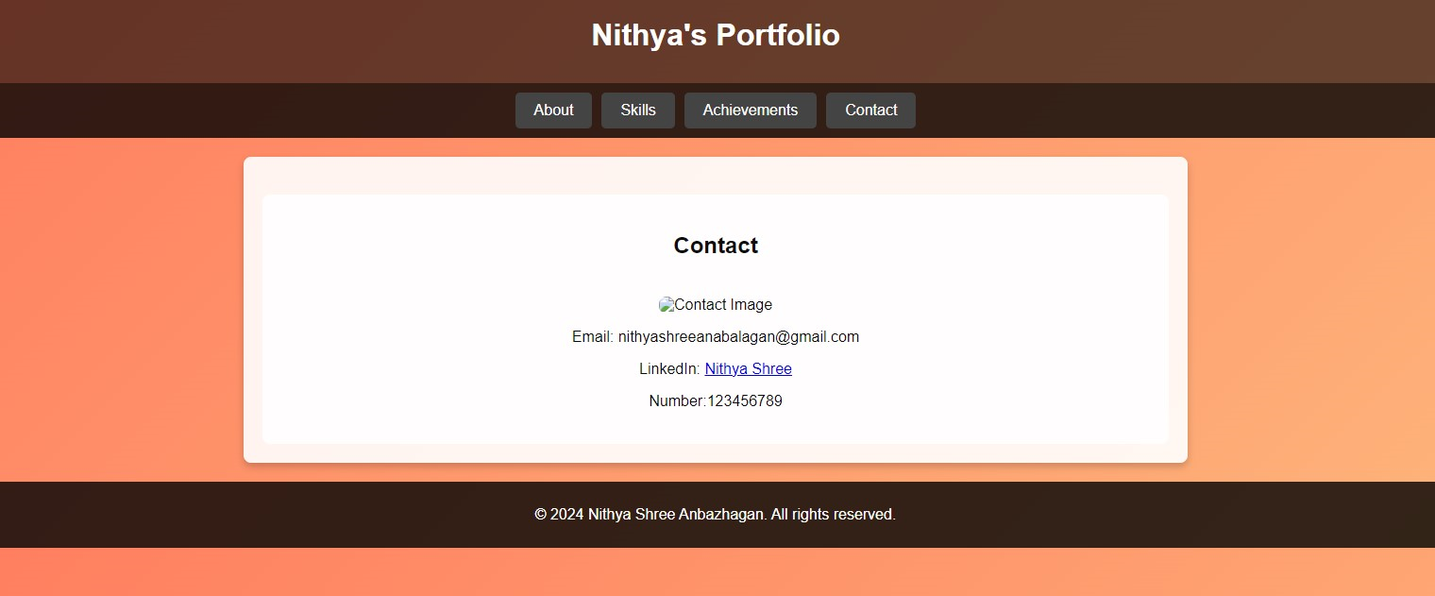

3. Creation of Storage account(Blob creation).

<https://nithustr.blob.core.windows.net/nithustr/il_fullxfull.5261790822_jpj0.jpg>

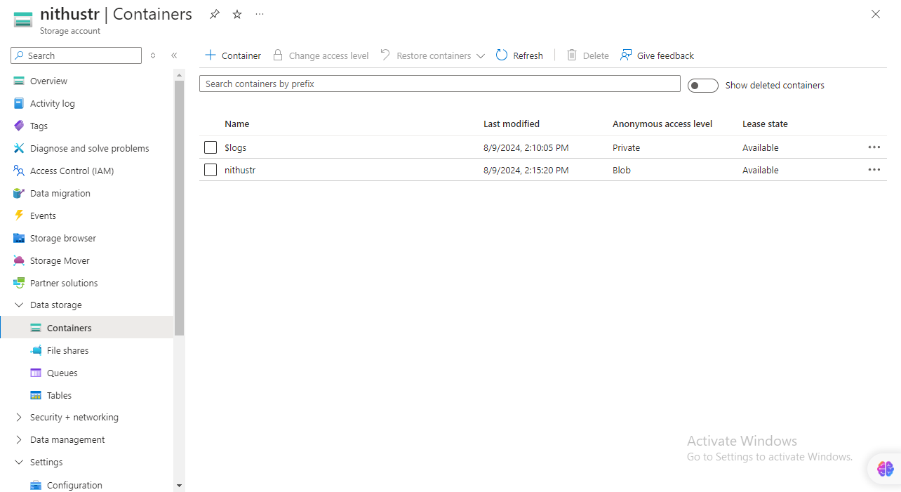

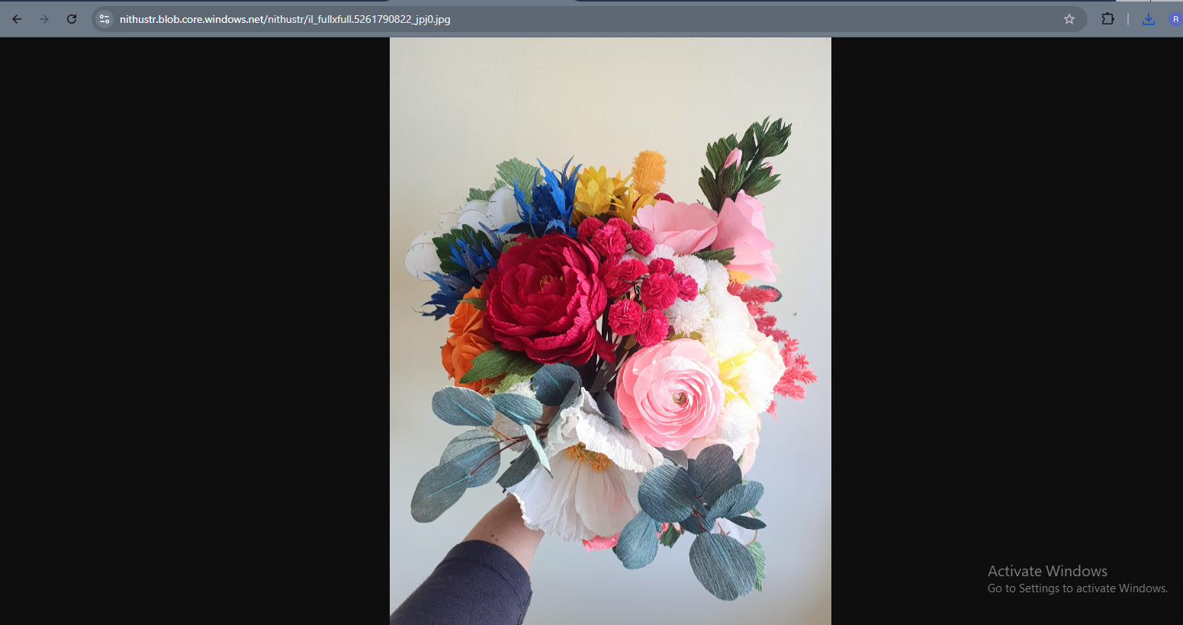

4.Creation of static web apps to deploy git repository:

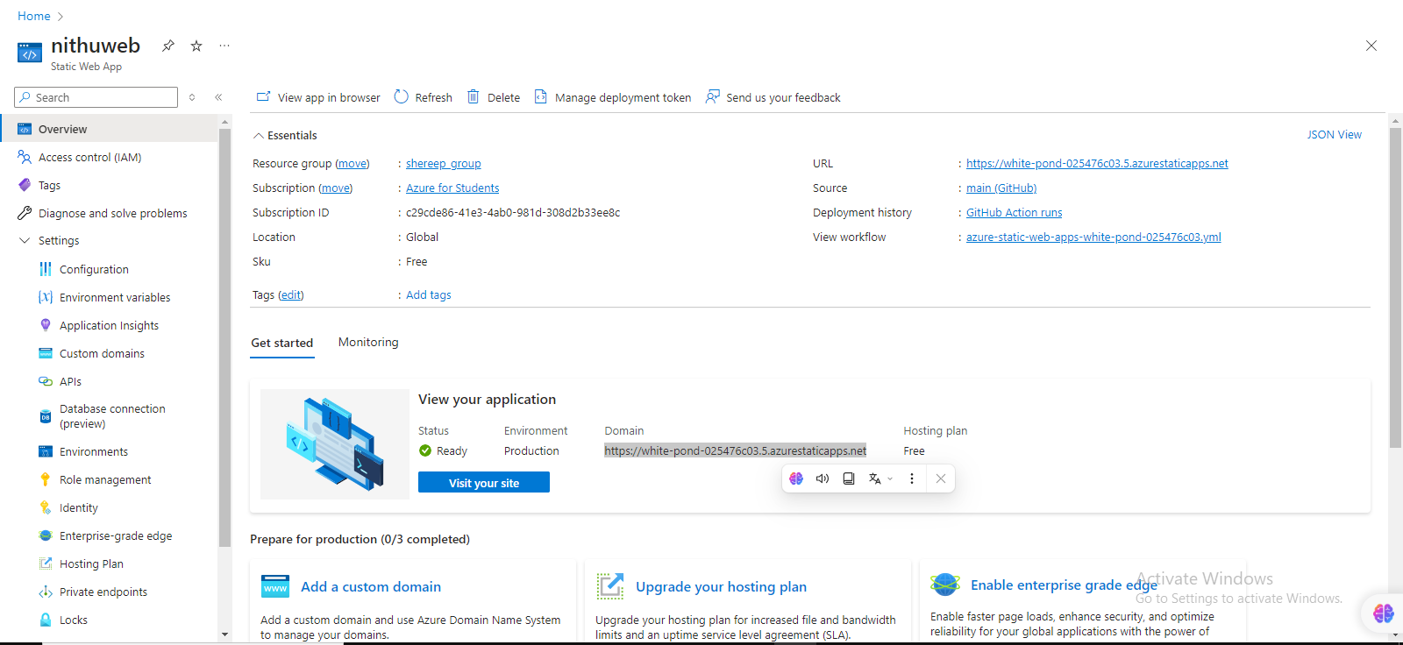

<https://white-pond-025476c03.5.azurestaticapps.net>







